**SQL Training**

### Attention

1. The <XXXX> used in this article represents the employee ID. Please replace it with your own employee ID.

### Create data object

#### Create tables and table indexes

Table ：CUX_OM_CUSTOMERS_XXXX

For storing customer information。

| Field | Type | Nullable | Default Value | Description |
| --- | --- | --- | --- | --- |
|  |  |  |  |  |
| CUSTOMER_ID | BIGINT | N |  |  |
| CUSTOMER_NUMBER | VARCHAR(30) | N |  |  |
| CUSTOMER_NAME | VARCHAR(100) | N |  |  |
| TELEPHONE | VARCAHR(50) | Y |  |  |
| START_DATE_ACTIVE | DATE | Y |  |  |
| END_DATE_ACTIVE | DATE | Y |  |  |
| CREATED_BY | BIGINT | N |  |  |
| CREATION_DATE | DATE | N |  |  |
| LAST_UPDATED_BY | BIGINT | N |  |  |
| LAST_UPDATE_DATE | DATE | N |  |  |
| LAST_UPDATE_LOGIN | BIGINT | Y |  |  |

Create indexes：

| Index | Unique | Field | Description |
| --- | --- | --- | --- |
|  |  |  |  |
| CUX_OM_CUSTOMERS_XXXX_U1 | Y | CUSTOMER_ID |  |
| CUX_OM_CUSTOMERS_XXXX_U2 | Y | CUSTOMER_NUMBER |  |
| CUX_OM_CUSTOMERS_XXXX_U3 | Y | CUSTOMER_NAME |  |

Table：CUX_OM_ITEMS_XXXX

For storing product information。

| Field | Type | Nullable | Default Value | Description |
| --- | --- | --- | --- | --- |
|  |  |  |  |  |
| ITEM_ID | BIGINT | N |  |  |
| ITEM_NUMBER | VARCHAR(30) | N |  |  |
| ITEM_NAME | VARCHAR(100) | N |  |  |
| UOM_CODE | VARCHAR(25) | Y |  |  |
| START_DATE_ACTIVE | DATE | Y |  |  |
| END_DATE_ACTIVE | DATE | Y |  |  |
| CREATED_BY | BIGINT | N |  |  |
| CREATION_DATE | DATE | N |  |  |
| LAST_UPDATED_BY | BIGINT | N |  |  |
| LAST_UPDATE_DATE | DATE | N |  |  |
| LAST_UPDATE_LOGIN | BIGINT | Y |  |  |

Create indexes：

| Index | Unique | Field | Description |
| --- | --- | --- | --- |
|  |  |  |  |
| CUX_OM_ITEMS_XXXX_U1 | Y | ITEM_ID |  |
| CUX_OM_ITEMS_XXXX_U2 | Y | ITEM_NUMBER |  |

table：CUX_OM_HEADERS_XXXX

For storing sales order header information。

| Field | Type | Nullable | DefaultValue | Description |
| --- | --- | --- | --- | --- |
|  |  |  |  |  |
| HEADER_ID | BIGINT | N |  |  |
| ORG_ID | BIGINT | Y | 101 |  |
| ORDER_NUMBER | VARCHAR(30) | N |  |  |
| CUSTOMER_ID | BIGINT | Y |  |  |
| ORDER_DATE | DATE | N |  |  |
| ORDER_STATUS | VARCHAR(30) | Y |  | status list:  UNAPPROVED  APPROVED  CANCELLED  CLOSED |
| DESCRIPTION | VARCHAR(240) | Y |  |  |
| CREATED_BY | BIGINT | N |  |  |
| CREATION_DATE | DATE | N |  |  |
| LAST_UPDATED_BY | BIGINT | N |  |  |
| LAST_UPDATE_DATE | DATE | N |  |  |
| LAST_UPDATE_LOGIN | BIGINT | Y |  |  |
| ATTRIBUTE_CATEGORY | VARCHAR(30) | Y |  |  |
| ATTRIBUTE1 | VARCHAR(150) | Y |  |  |
| ATTRIBUTE2 | VARCHAR(150) | Y |  |  |
| ATTRIBUTE3 | VARCHAR(150) | Y |  |  |
| ATTRIBUTE4 | VARCHAR(150) | Y |  |  |
| ATTRIBUTE5 | VARCHAR(150) | Y |  |  |
| ATTRIBUTE6 | VARCHAR(150) | Y |  |  |
| ATTRIBUTE7 | VARCHAR(150) | Y |  |  |
| ATTRIBUTE8 | VARCHAR(150) | Y |  |  |
| ATTRIBUTE9 | VARCHAR(150) | Y |  |  |
| ATTRIBUTE10 | VARCHAR(150) | Y |  |  |
| ATTRIBUTE11 | VARCHAR(150) | Y |  |  |
| ATTRIBUTE12 | VARCHAR(150) | Y |  |  |
| ATTRIBUTE13 | VARCHAR(150) | Y |  |  |
| ATTRIBUTE14 | VARCHAR(150) | Y |  |  |
| ATTRIBUTE15 | VARCHAR(150) | Y |  |  |

Create Indexes：

| Index | Unique | Field | Description |
| --- | --- | --- | --- |
|  |  |  |  |
| CUX_OM_HEADERS_XXXX _U1 | Y | HEADER_ID |  |
| CUX_OM_HEADERS_XXXX _U2 | Y | ORDER_NUMBER |  |
| CUX_OM_HEADERS_XXXX _N1 |  | CUSTOMER_ID |  |

Table：CUX_OM_LINES_XXXX

For storing sales order line information。

| Field | Type | Nullable | Default Value | Description |
| --- | --- | --- | --- | --- |
|  |  |  |  |  |
| LINE_ID | BIGINT | N |  |  |
| HEADER_ID | BIGINT | N |  |  |
| LINE_NUMBER | VARCHAR(30) | N |  |  |
| ITEM_ID | BIGINT | N |  |  |
| UNIT_PRICE | DECIMAL(10,2) | Y |  |  |
| QUANTITY | DECIMAL(10,2) | Y |  |  |
| DESCRIPTION | VARCHAR(240) | Y |  |  |
| ADDITION1 | VARCHAR(150) | Y |  |  |
| ADDITION2 | VARCHAR(150) | Y |  |  |
| ADDITION3 | VARCHAR(150) | Y |  |  |
| ADDITION4 | VARCHAR(150) | Y |  |  |
| ADDITION5 | VARCHAR(150) | Y |  |  |
| CREATED_BY | BIGINT | N |  |  |
| CREATION_DATE | DATE | N |  |  |
| LAST_UPDATED_BY | BIGINT | N |  |  |
| LAST_UPDATE_DATE | DATE | N |  |  |
| LAST_UPDATE_LOGIN | BIGINT | Y |  |  |
| ATTRIBUTE_CATEGORY | VARCHAR(30) | Y |  |  |
| ATTRIBUTE1 | VARCHAR(150) | Y |  |  |
| ATTRIBUTE2 | VARCHAR(150) | Y |  |  |
| ATTRIBUTE3 | VARCHAR(150) | Y |  |  |
| ATTRIBUTE4 | VARCHAR(150) | Y |  |  |
| ATTRIBUTE5 | VARCHAR(150) | Y |  |  |
| ATTRIBUTE6 | VARCHAR(150) | Y |  |  |
| ATTRIBUTE7 | VARCHAR(150) | Y |  |  |
| ATTRIBUTE8 | VARCHAR(150) | Y |  |  |
| ATTRIBUTE9 | VARCHAR(150) | Y |  |  |
| ATTRIBUTE10 | VARCHAR(150) | Y |  |  |
| ATTRIBUTE11 | VARCHAR(150) | Y |  |  |
| ATTRIBUTE12 | VARCHAR(150) | Y |  |  |
| ATTRIBUTE13 | VARCHAR(150) | Y |  |  |
| ATTRIBUTE14 | VARCHAR(150) | Y |  |  |
| ATTRIBUTE15 | VARCHAR(150) | Y |  |  |

Create Indexes：

| Index | Unique | Field | Description |
| --- | --- | --- | --- |
|  |  |  |  |
| CUX_OM_LINES_XXXX _U1 | Y | LINE_ID |  |
| CUX_OM_LINES_XXXX _N1 |  | HEADER_ID |  |
| CUX_OM_LINES_XXXX _N2 |  | ITEM_ID |  |

#### Import data

excel：《1 – Table Data.xls》

1．CUX_OM_CUSTOMERS_XXXX

2．CUX_OM_ITEMS_XXXX

4．CUX_OM_HEADERS_XXXX

5．CUX_OM_LINES_XXXX

### Questions

#### NO.01

Please create the above objects in the database: table, table index。

Answer:

1．CUX_OM_CUSTOMERS_46323

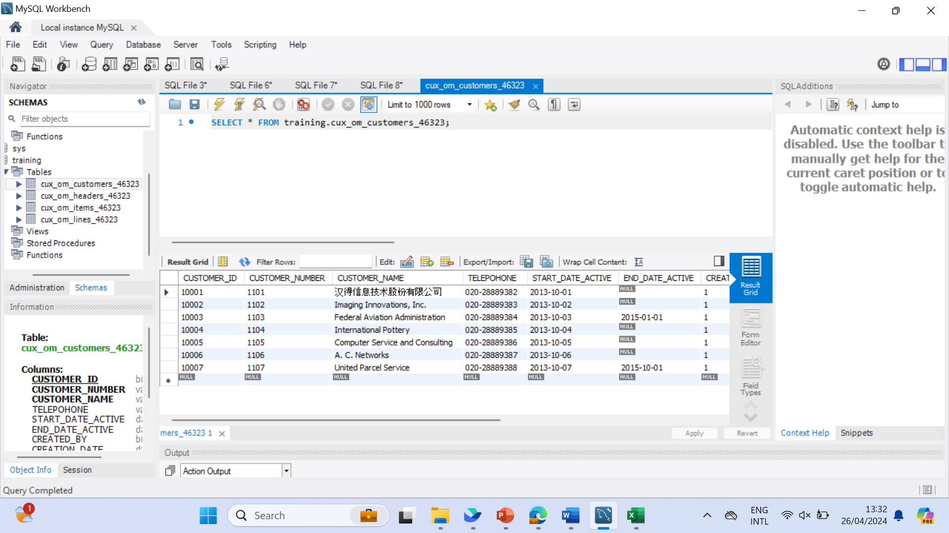



2．CUX_OM_ITEMS_46323

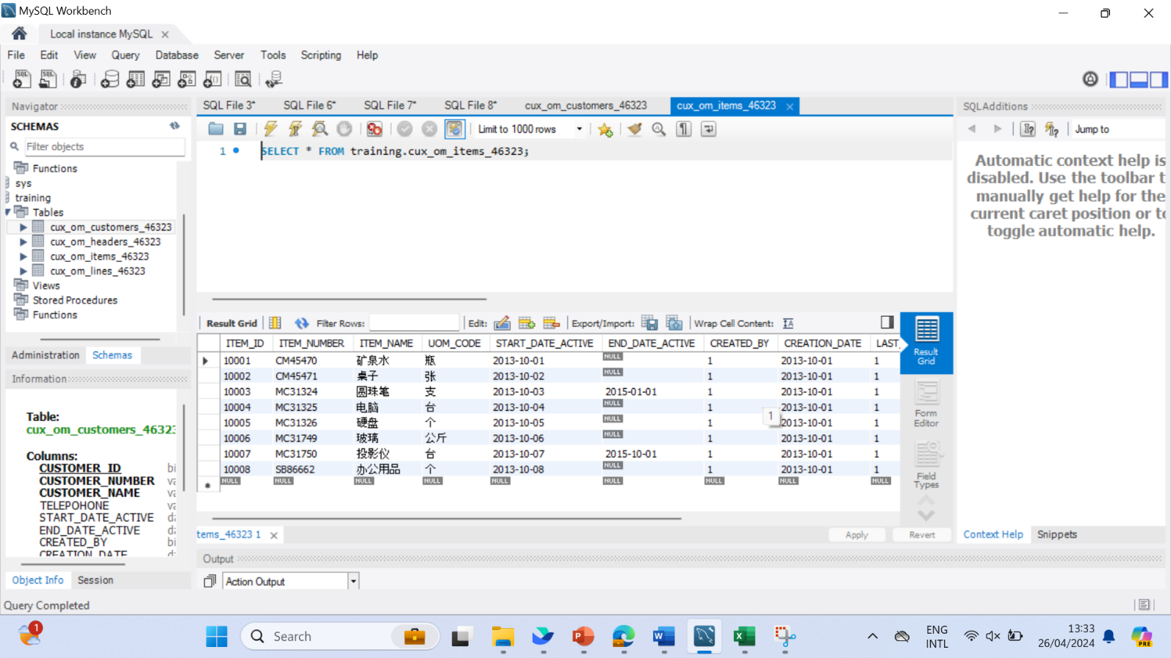



3．CUX_OM_HEADERS_46323

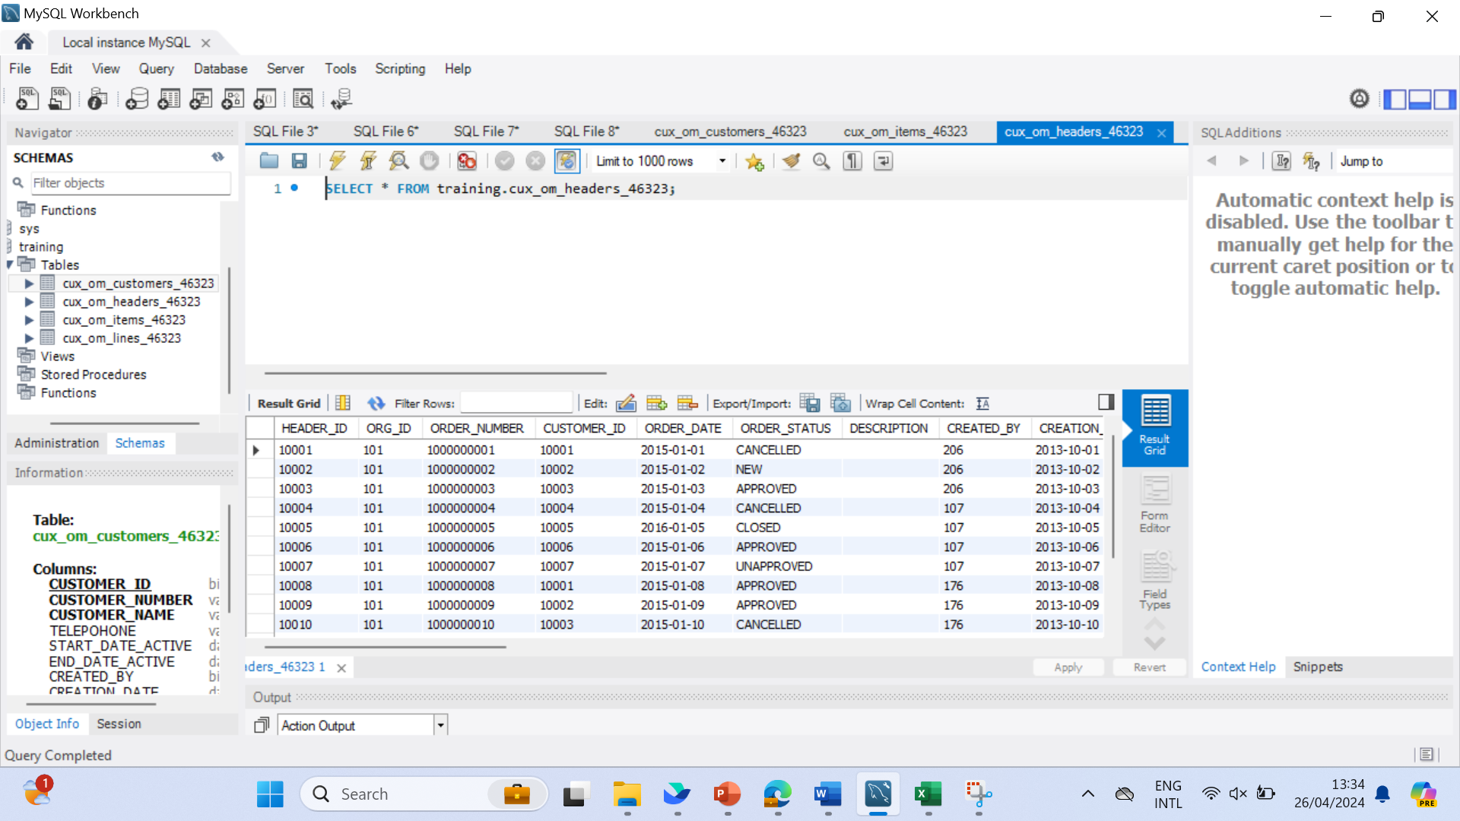

CREATE TABLE `training`.`CUX_OM_HEADERS_46323` (

HEADER_ID bigint not null auto_increment,

ORG_ID bigint default(101),

ORDER_NUMBER varchar(30) not null,

CUSTOMER_ID bigint not null,

ORDER_DATE date not null,

ORDER_STATUS varchar(30),

DESCRIPTION varchar(240),

CREATED_BY bigint not null,

CREATION_DATE date not null,

LAST_UPDATED_BY bigint not null,

LAST_UPDATED_DATE date not null,

LAST_UPDATE_LOGIN bigint,

ATTRIBUTE_CATEGORY varchar(30),

ATTRIBUTE1 varchar(150),

ATTRIBUTE2 varchar(150),

ATTRIBUTE3 varchar(150),

ATTRIBUTE4 varchar(150),

ATTRIBUTE5 varchar(150),

ATTRIBUTE6 varchar(150),

ATTRIBUTE7 varchar(150),

ATTRIBUTE8 varchar(150),

ATTRIBUTE9 varchar(150),

ATTRIBUTE10 varchar(150),

ATTRIBUTE11 varchar(150),

ATTRIBUTE12 varchar(150),

ATTRIBUTE13 varchar(150),

ATTRIBUTE14 varchar(150),

ATTRIBUTE15 varchar(150),

PRIMARY KEY (`HEADER_ID`),

UNIQUE INDEX `CUX_OM_CUSTOMERS_46323_U1` (`HEADER_ID`) VISIBLE,

UNIQUE INDEX `CUX_OM_CUSTOMERS_46323_U2` (`ORDER_NUMBER_BY`) VISIBLE,

INDEX `CUX_OM_CUSTOMERS_46323_N1` (`CUSTOMER_ID`) VISIBLE);

4．CUX_OM_LINES_46323

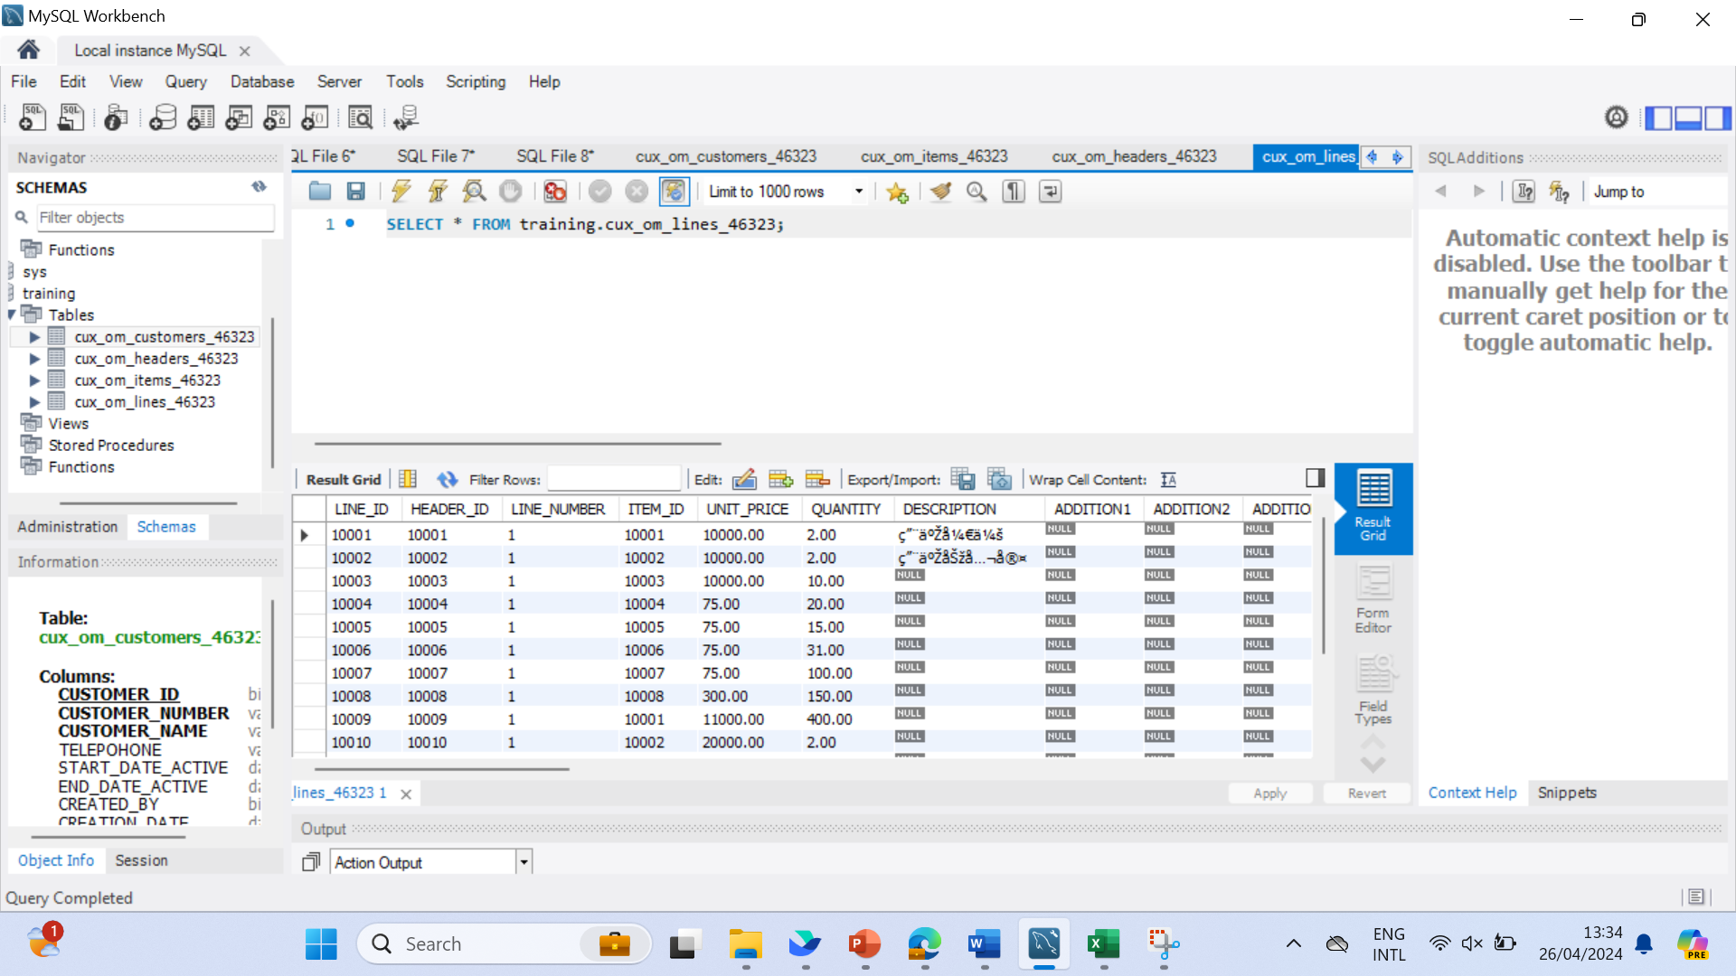

CREATE TABLE `training`.`CUX_OM_LINES_46323` (

LINE_ID bigint not null auto_increment,

HEADER_ID bigint,

LINE_NUMBER varchar(30) not null,

ITEM_ID bigint not null,

UNIT_PRICE decimal(10,2),

QUANTITY decimal(10,2),

DESCRIPTION varchar(240),

ADDITION1 varchar(150),

ADDITION2 varchar(150),

ADDITION3 varchar(150),

ADDITION4 varchar(150),

ADDITION5 varchar(150),

CREATED_BY bigint not null,

CREATION_DATE date not null,

LAST_UPDATED_BY bigint not null,

LAST_UPDATE_DATE date not null,

LAST_UPDATE_LOGIN bigint,

ATTRIBUTE_CATEGORY varchar(30),

ATTRIBUTE1 varchar(150),

ATTRIBUTE2 varchar(150),

ATTRIBUTE3 varchar(150),

ATTRIBUTE4 varchar(150),

ATTRIBUTE5 varchar(150),

ATTRIBUTE6 varchar(150),

ATTRIBUTE7 varchar(150),

ATTRIBUTE8 varchar(150),

ATTRIBUTE9 varchar(150),

ATTRIBUTE10 varchar(150),

ATTRIBUTE11 varchar(150),

ATTRIBUTE12 varchar(150),

ATTRIBUTE13 varchar(150),

ATTRIBUTE14 varchar(150),

ATTRIBUTE15 varchar(150),

PRIMARY KEY (`LINE_ID`),

UNIQUE INDEX `CUX_OM_CUSTOMERS_46323_U1` (`LINE_ID`) VISIBLE,

INDEX `CUX_OM_CUSTOMERS_46323_N1` (`HEADER_ID`) VISIBLE,

INDEX `CUX_OM_CUSTOMERS_46323_N2` (`ITEM_ID`) VISIBLE);

#### NO.02

Please import the corresponding table data in the file: "1 – Table Data.xlsx" into the table。

Answer:

1．CUX_OM_CUSTOMERS_46323

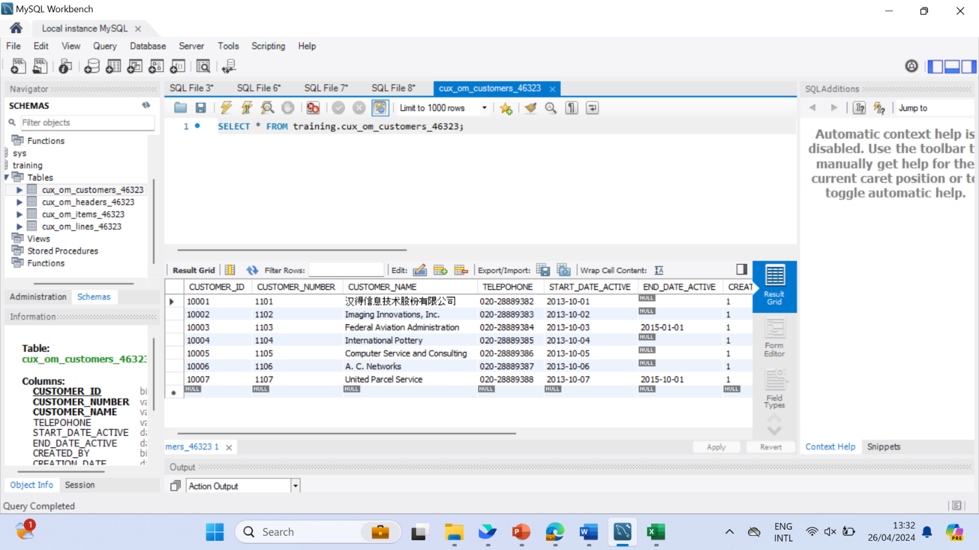

2．CUX_OM_ITEMS_46323



3．CUX_OM_HEADERS_46323



4．CUX_OM_LINES_46323



#### NO.03

Create a view：CUX_OM_HEADERS_V

* view：CUX_OM_HEADERS_V

| Field | Type | Nullable | DefaultValue | Description |
| --- | --- | --- | --- | --- |
|  |  |  |  |  |
| HEADER_ID | BIGINT | N |  |  |
| ORDER_NUMBER | VARCHAR(30) | N |  |  |
| CUSTOMER_ID | BIGINT | Y |  |  |
| ORDER_DATE | DATE | N |  |  |
| ORDER_STATUS | VARCHAR(30) | Y |  | status list:  UNAPPROVED  APPROVED  CANCELLED  CLOSED |
| DESCRIPTION | VARCHAR(240) | Y |  |  |
| CREATED_BY | BIGINT | N |  |  |
| CREATION_DATE | DATE | N |  |  |
| LAST_UPDATED_BY | BIGINT | N |  |  |
| LAST_UPDATE_DATE | DATE | N |  |  |
| LAST_UPDATE_LOGIN | BIGINT | Y |  |  |
| ATTRIBUTE_CATEGORY | VARCHAR(30) | Y |  |  |
| ATTRIBUTE1 | VARCHAR(150) | Y |  |  |
| ATTRIBUTE2 | VARCHAR(150) | Y |  |  |
| ATTRIBUTE3 | VARCHAR(150) | Y |  |  |
| ATTRIBUTE4 | VARCHAR(150) | Y |  |  |
| ATTRIBUTE5 | VARCHAR(150) | Y |  |  |
| ATTRIBUTE6 | VARCHAR(150) | Y |  |  |
| ATTRIBUTE7 | VARCHAR(150) | Y |  |  |
| ATTRIBUTE8 | VARCHAR(150) | Y |  |  |
| ATTRIBUTE9 | VARCHAR(150) | Y |  |  |
| ATTRIBUTE10 | VARCHAR(150) | Y |  |  |
| ATTRIBUTE11 | VARCHAR(150) | Y |  |  |
| ATTRIBUTE12 | VARCHAR(150) | Y |  |  |
| ATTRIBUTE13 | VARCHAR(150) | Y |  |  |
| ATTRIBUTE14 | VARCHAR(150) | Y |  |  |
| ATTRIBUTE15 | VARCHAR(150) | Y |  |  |
| CUSTOMER_NUMBER | VARCHAR(30) |  |  |  |
| CUSTOMER_NAME | VARCHAR(100) |  |  |  |
| TELEPHONE | VARCHAR(50) | Y |  |  |

#### Answer:

create view training.`CUX_OM_HEADERS_V`

as

select

HEADER_ID , ORDER_NUMBER, training.cux_om_customers_46323.CUSTOMER_ID, ORDER_DATE, ORDER_STATUS, DESCRIPTION, training.cux_om_headers_46323.CREATED_BY,

training.cux_om_headers_46323.CREATION_DATE, training.cux_om_headers_46323.LAST_UPDATED_BY, training.cux_om_headers_46323.LAST_UPDATE_DATE, training.cux_om_headers_46323.LAST_UPDATE_LOGIN, ATTRIBUTE_CATEGORY,

ATTRIBUTE1, ATTRIBUTE2, ATTRIBUTE3, ATTRIBUTE4, ATTRIBUTE5, ATTRIBUTE6, ATTRIBUTE7, ATTRIBUTE8

,ATTRIBUTE9, ATTRIBUTE10, ATTRIBUTE11, ATTRIBUTE12, ATTRIBUTE13, ATTRIBUTE14, ATTRIBUTE15,

training.cux_om_customers_46323.CUSTOMER_NUMBER, training.cux_om_customers_46323.CUSTOMER_NAME, training.cux_om_customers_46323.TELEPHONE

from training.cux_om_headers_46323

join training.cux_om_customers_46323

on training.cux_om_customers_46323.CUSTOMER_ID = training.cux_om_headers_46323.CUSTOMER_ID;

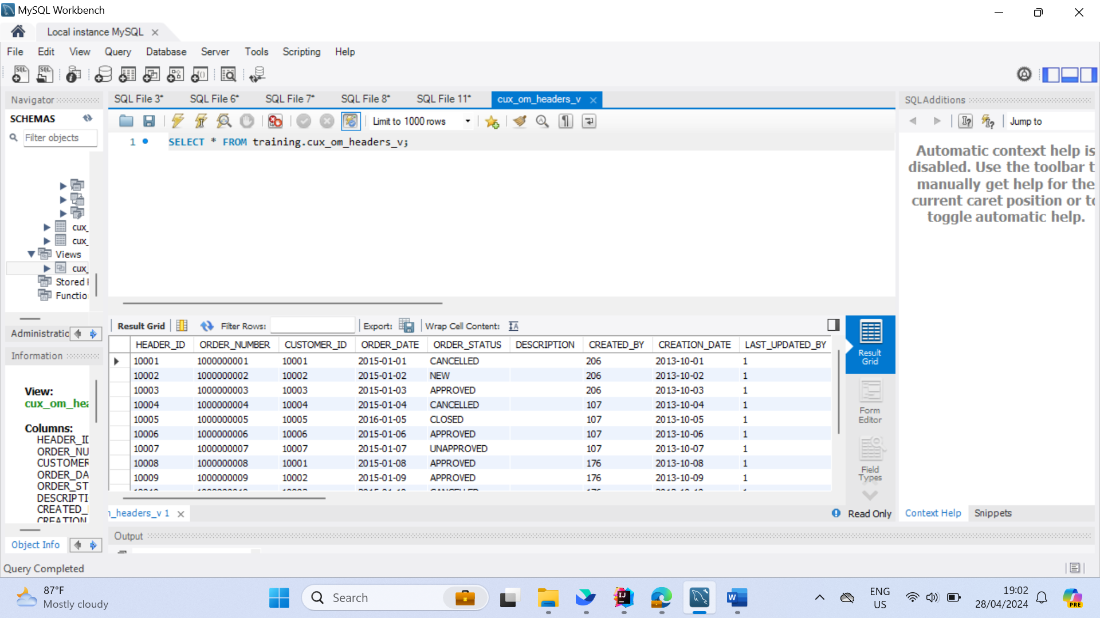

#### NO.04

Write SQL to display the following information and sort it by customer_number and order_number in ascending order。

|  |  |  |  |  |  |
| --- | --- | --- | --- | --- | --- |
| order_number | customer_number | customer_name | order_date | order_status | description |
|  |  |  |  |  |  |
|  |  |  |  |  |  |

#### Answer:

select ORDER_NUMBER, CUSTOMER_NUMBER, CUSTOMER_NAME, ORDER_DATE, ORDER_STATUS, DESCRIPTION

from training.cux_om_customers_46323, training.cux_om_headers_46323

order by CUSTOMER_NUMBER and ORDER_NUMBER asc;

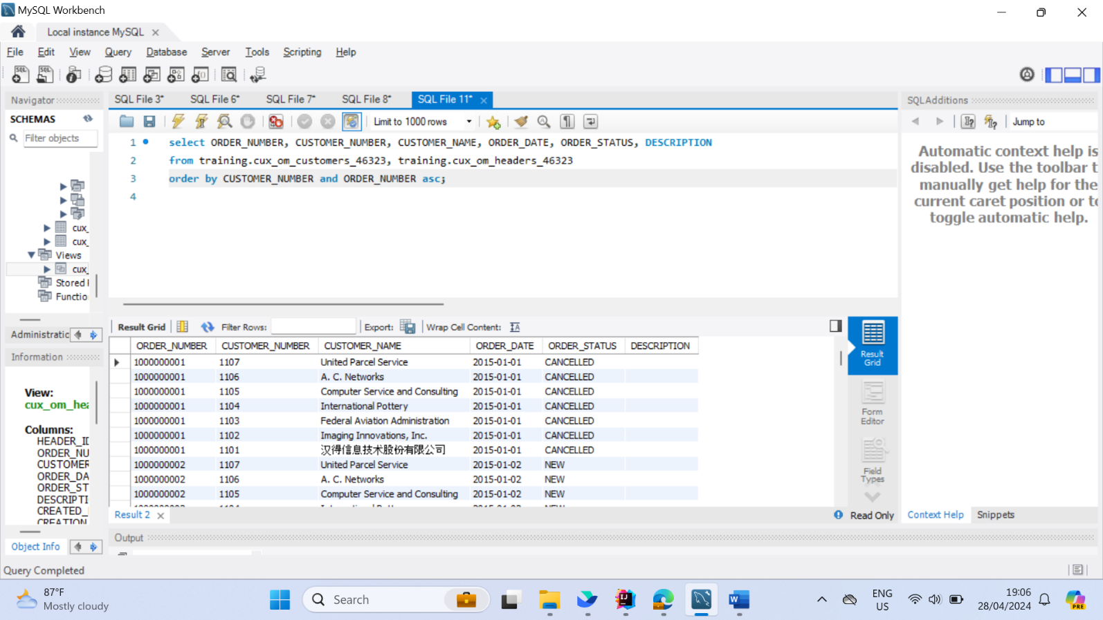

#### NO.05

Write SQL to display order and order line information, sorted by order number and line number in ascending order (including orders with all statuses)

|  |  |  |  |  |  |  |
| --- | --- | --- | --- | --- | --- | --- |
| order_number | customer_name | order_date | order_status | line_number | item_number | item_name |
|  |  |  |  |  |  |  |

#### Answer:

select ORDER_NUMBER, CUSTOMER_NAME, ORDER_DATE, ORDER_STATUS, LINE_NUMBER, ITEM_NUMBER, ITEM_NAME

from training.cux_om_customers_46323, training.cux_om_headers_46323, training.cux_om_items_46323, training.cux_om_lines_46323

order by CUSTOMER_NUMBER and LINE_NUMBER asc;

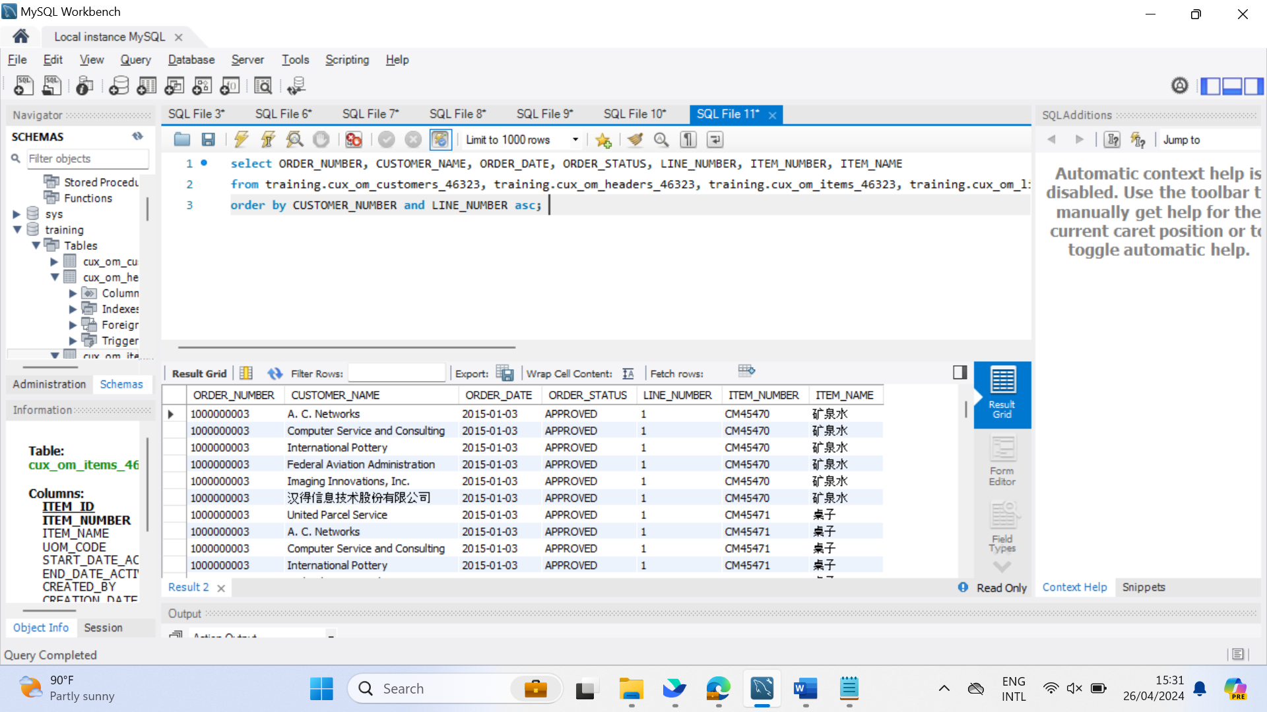

#### NO.06

Write SQL to display products purchased by customers

|  |  |  |  |  |
| --- | --- | --- | --- | --- |
| customer_number | customer_number | item_number | item_name | uom_code |
| 1101 | 汉得信息技术股份有限公司 | SB86662 | 办公用品 | 个 |

#### Answer:

select CUSTOMER_NUMBER, CUSTOMER_NAME, ITEM_NUMBER, ITEM_NAME, UOM_CODE

from training.cux_om_items_46323

join training.cux_om_customers_46323

on training.cux_om_items_46323.ITEM_ID = training.cux_om_customers_46323.CUSTOMER_ID

join training.cux_om_headers_46323

on training.cux_om_customers_46323.CUSTOMER_ID = training.cux_om_headers_46323.CUSTOMER_ID

where training.cux_om_headers_46323.ORDER_STATUS = "APPROVED";

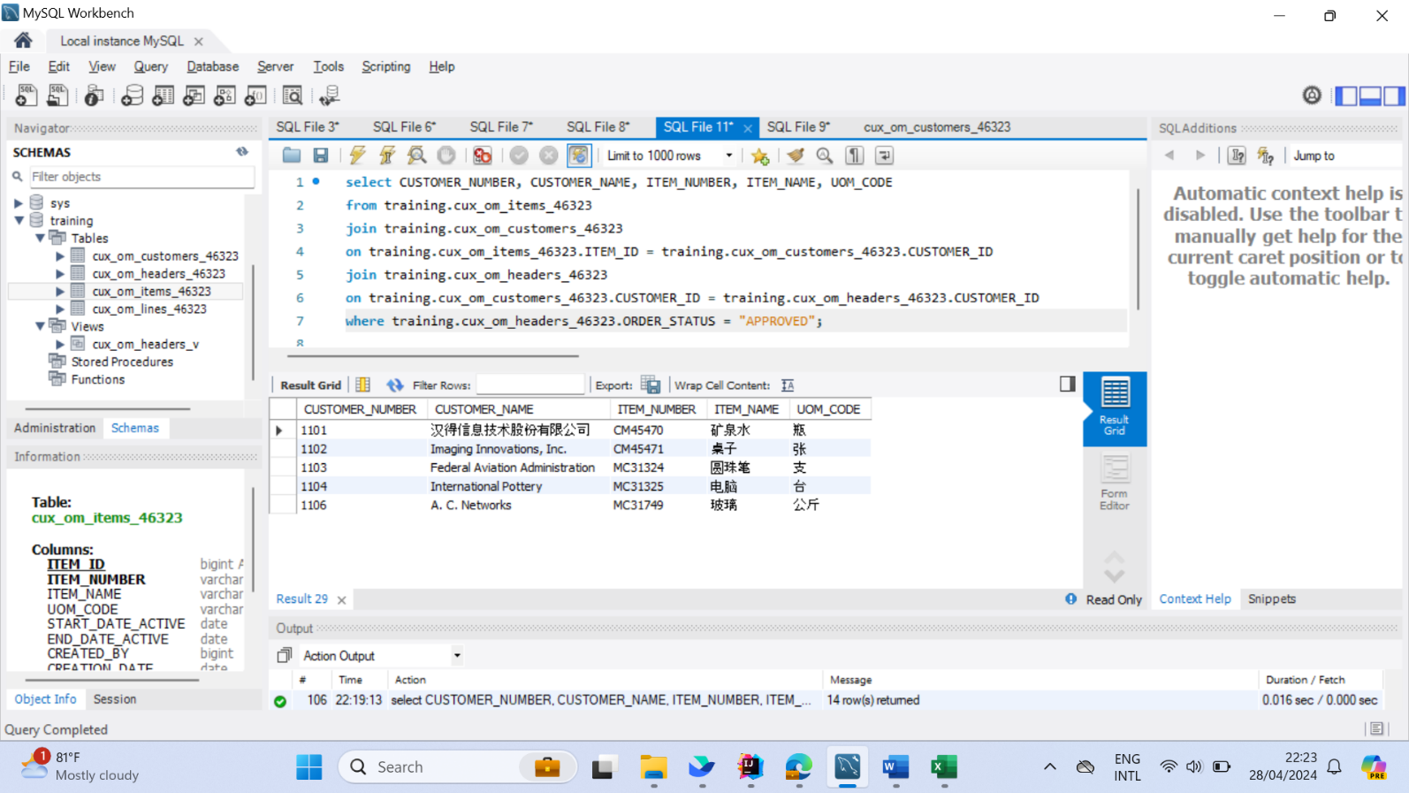

#### NO.07

Write SQL to count all orders (excluding canceled orders) and calculate the average sales unit price and the highest and lowest unit price by product.

|  |  |  |  |  |
| --- | --- | --- | --- | --- |
| item_number | item_name | average_unit_price | highest_unit_price | lowest_unit_price |
|  |  |  |  |  |

#### Answer:

select ITEM_NUMBER, ITEM_NAME, avg(distinct UNIT_PRICE) as average_unit_price, max(UNIT_PRICE) as highest_unit_price, min(UNIT_PRICE) as lowest_unit_price

from training.cux_om_items_46323

join training.cux_om_lines_46323

on training.cux_om_items_46323.ITEM_ID = training.cux_om_lines_46323.ITEM_ID

join training.cux_om_headers_46323

on training.cux_om_items_46323.ITEM_ID = training.cux_om_headers_46323.CUSTOMER_ID

where training.cux_om_headers_46323.ORDER_STATUS != "CANCELLED"

group by ITEM_NUMBER;

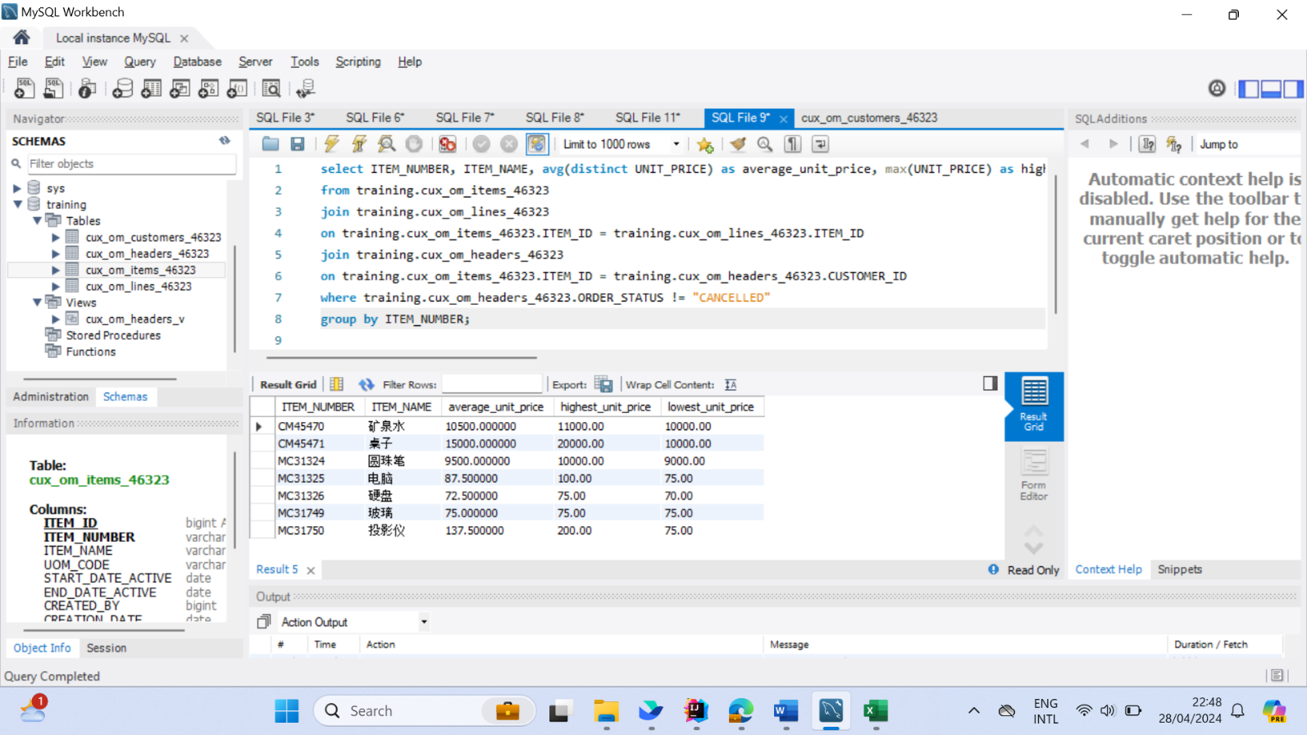

#### NO.08

Write SQL to query customer information about canceled orders.

|  |  |  |  |  |
| --- | --- | --- | --- | --- |
| customer_number | customer_name | telephone | start_date_active | end_date_active |
|  |  |  |  |  |

#### Answer:

select CUSTOMER_NUMBER, CUSTOMER_NAME, TELEPHONE, START_DATE_ACTIVE, END_DATE_ACTIVE

from training.cux_om_customers_46323

join training.cux_om_headers_46323

on training.cux_om_customers_46323.CUSTOMER_ID = training.cux_om_headers_46323.CUSTOMER_ID

where ORDER_STATUS = "CANCELLED"

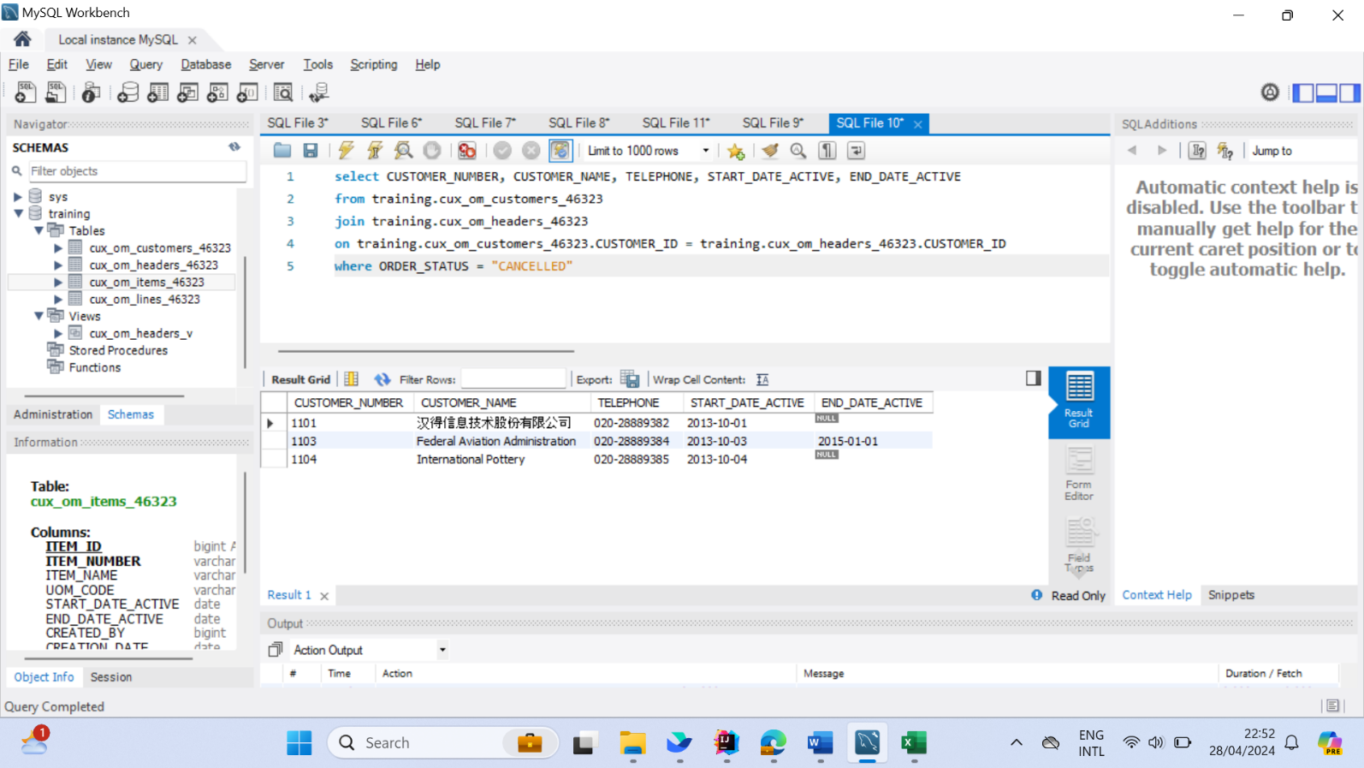

#### NO.09

Write SQL to count the company's total sales in 2015. (All orders with status CANCELLED are excluded from statistics)

|  |
| --- |
| Total Sales |
|  |

#### Answer:

SELECT SUM(l.UNIT_PRICE * l.QUANTITY) AS `Total Sales`

FROM cux_om_lines_46323 l

JOIN cux_om_items_46323 i ON l.ITEM_ID = i.ITEM_ID

JOIN cux_om_headers_46323 h ON h.HEADER_ID = l.HEADER_ID

WHERE h.ORDER_STATUS != 'CANCELLED' AND YEAR(h.ORDER_DATE) = 2015;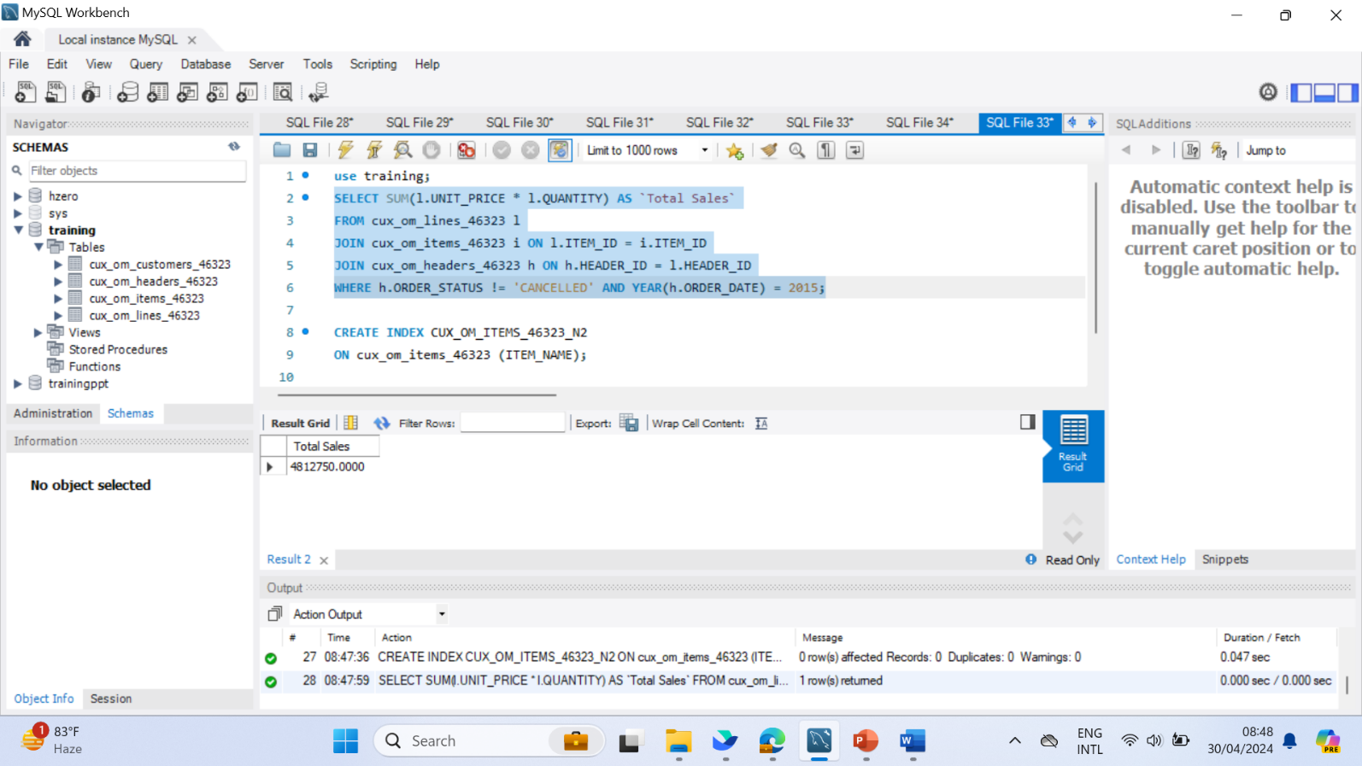

#### NO.10

Write a script to add an index to the table: CUX_OM_ITEMS_XXXX: a normal index, and the applicable field: ITEM_NAME.

CREATE INDEX CUX_OM_ITEMS_46323_N2

ON cux_om_items_46323 (ITEM_NAME);

